AP Biology Name _________________________
Chapter 9 Guided Reading: Cellular Respiration and Fermentation
10ed

Photosynthesis and cellular respiration are key ecological concepts involved with energy flow. Use figure 9.2 from your text to label the missing parts in the following figure.
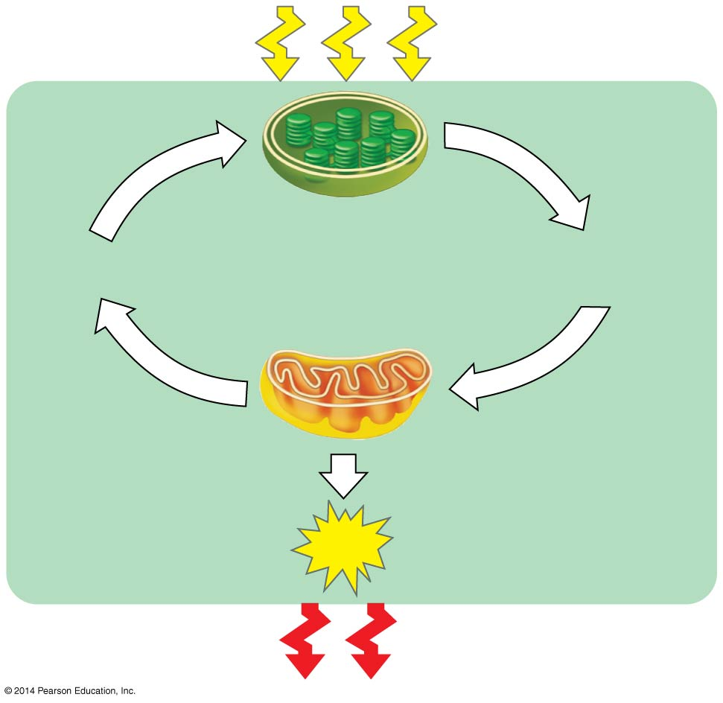
- Explain the difference between fermentation and aerobic respiration.

- Give the formula (with names) for the catabolic degradation of glucose by cellular respiration.

- Both cellular respiration and photosynthesis are redox reactions. What is the difference between oxidation and reduction?

- The following is a generalized formula for a redox reaction:

Xe ⁻ + Y → X + Ye ⁻
Draw an arrow showing which components (X or Y) is oxidized and which is reduced. _______________ is the reducing agent in this reaction, and _____________ is the oxidizing agent.
- When compounds lose electrons, they __________ energy; when compounds gain electrons, they ____________ energy.

- In cellular respiration, electrons are not transferred directly from glucose to oxygen. Following the movement of hydrogens allows you to follow the flow of electrons. What electron carrier is transferred to first?

- What are coenzymes?

- Describe what happens when NAD+ is reduced. What enzyme type is involved?

- For the following pair, which molecule is the oxidized form, and which is reduced? Which molecule holds higher potential energy? Which is lower potential energy?

 | Oxidized or Reduced? | Higher Energy/Lower Energy
NAD+
NADH

- What is the function of the electron transport chain in cellular respiration?

- Electron transport involves a series of electron carriers.

Where are these found in eukaryotic cells?______________________________.

Where are these found in respiring prokaryotic cells?______________________.
- What strongly electronegative atom, pulling electrons down the electron transport chain, is the final electron acceptor?

- Understanding the overall map of how cellular respiration works will make the details easier to learn. Use Figure 9.6 from your text to label the missing information in the following figure.
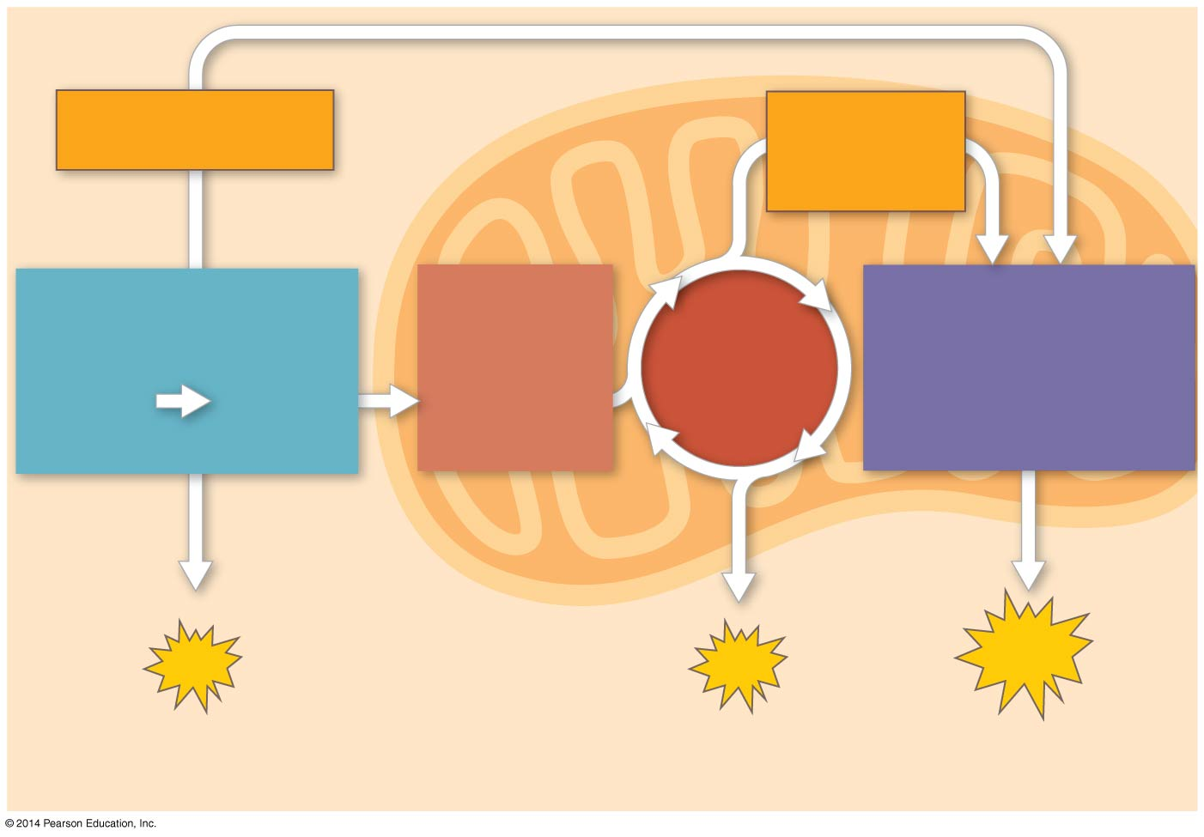

- Three types of phosphorylation are covered in the text, and two of these occur in cellular respiration. Explain how the electron transport chain is utilized in oxidative phosphorylation.

- Label the following figure to show the direct transfer of a phosphate from an organic substrate to ADP to form ATP.
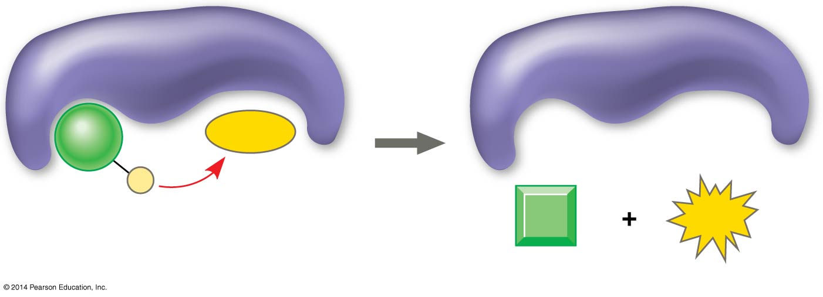

- What is the meaning of glycolysis? What occurs in this step of cellular respiration

- The starting product of glycolysis is the six-carbon sugar ______________, and the ending products are two _______________-carbon molecules of __________________.

- The following figures show a summary of glycolysis. Label the energy investment phase below and complete the figure. Then to Figure 9.9 on page 168 of your text to find the two specific steps where ATP is used.
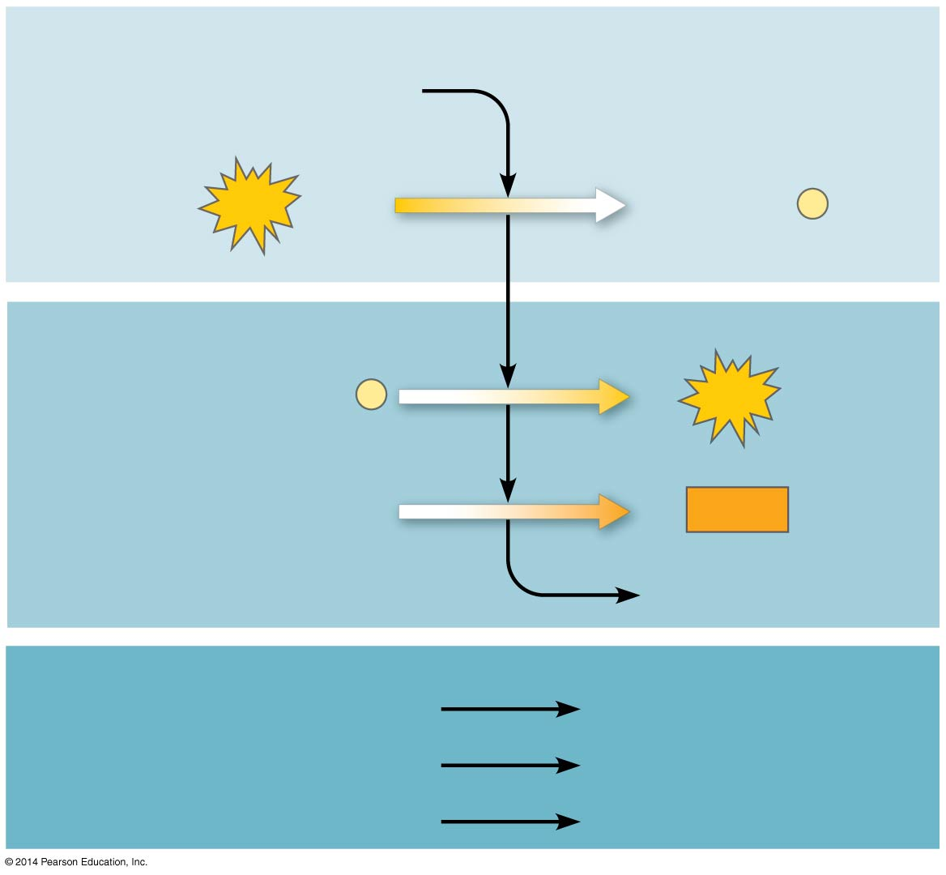
- Use the figure in Question 18. The second phase in glycolysis is the energy payoff phase. Label this phase and complete the figure. Note that it provides both ATP and NADH. Look at Figure 9.9 from your text to locate the two steps where ATP is formed and the one step where NADH is formed.

- Use the figure in Question 18. This final figure shows the net gain of energy for the cell after glycolysis. Most of energy is still present in the two molecules of pyruvate. Complete the following figure to show the net energy gains.

- Where does the glycolysis occur in the cell? Is oxygen required?

- To enter the citric acid cycle, pyruvate must enter the mitochondria by active transport. Three things are necessary to convert pyruvate to acetyl CoA. Complete the missing parts of the following figure and then explain the three steps in the conversion process.
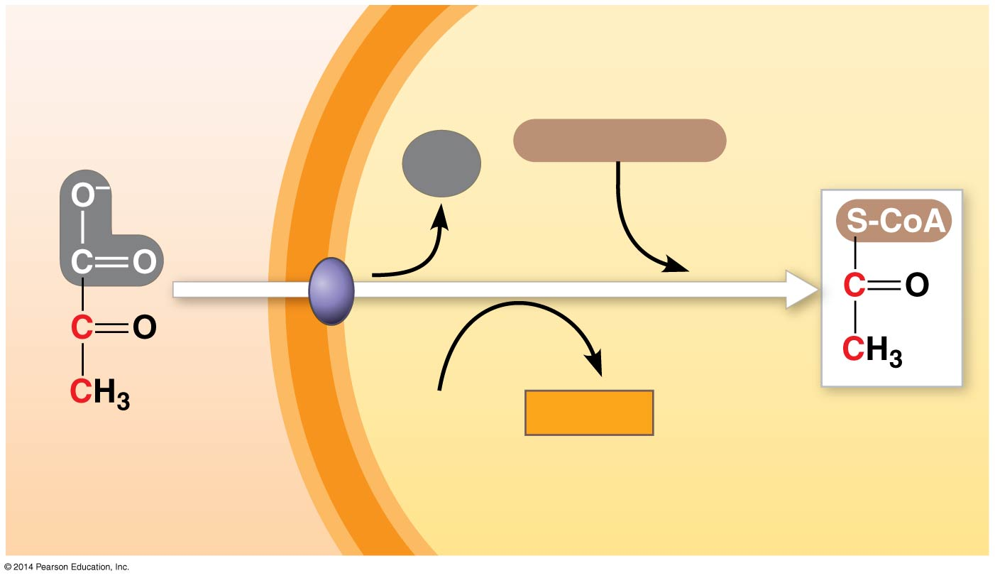
a.

b.

c.

- Use figure 9.11 from your text to help you answer the following summary questions about the citric acid cycle:
a. How many NADHs are formed?

b. How many total carbons are lost as pyruvate is oxidized?

c. The carbons are lost in which molecule?

d. How many FADH2 are formed?

e. How many ATPs are formed?

f. How many times does the citric acid cycle occur for each molecule of glucose?
- The step that converts pyruvate to acetyl CoA at the top of the diagram occurs twice per glucose. This oxidation of pyruvate accounts for two additional reduced _______________________ molecules and two molecules of CO2.

- Explain what has happened to each of the six carbons found in the original glucose molecule.

- Oxidative phosphorylation involves two components: the ETC and ATP synthesis. Referring to Figure 9.3 in your text, notice that each member of the ETC is lower free ___________________ than the preceding member of the chain, but higher in ________________. The molecule at zero free energy and the highest in electronegativity.

- Explain why oxygen is considered the ultimate electron acceptor.

- Oxygen stabilizes the electrons by combining with two hydrogen ions to form what compound?

- What are the two electron carrier molecules that feed electrons into the electron transport system?

- Using figure 9.14 in your text, explain the overall concept of how ATP synthase uses the flow of hydrogen ions to produce ATP.

- What is the role of the electron transport chain in the following H+ gradient across the inner mitochondrial membrane?

- Two key terms are chemiosmosis and proton-motive force. Relate both of these terms to the process of oxidative phosphorylation.
- Figure 9.15 in your text will help you understand the production of ATP in the mitochondria. Label the figure to study this process. Then use one color to trace the flow of electrons and another color to show the flow of protons.

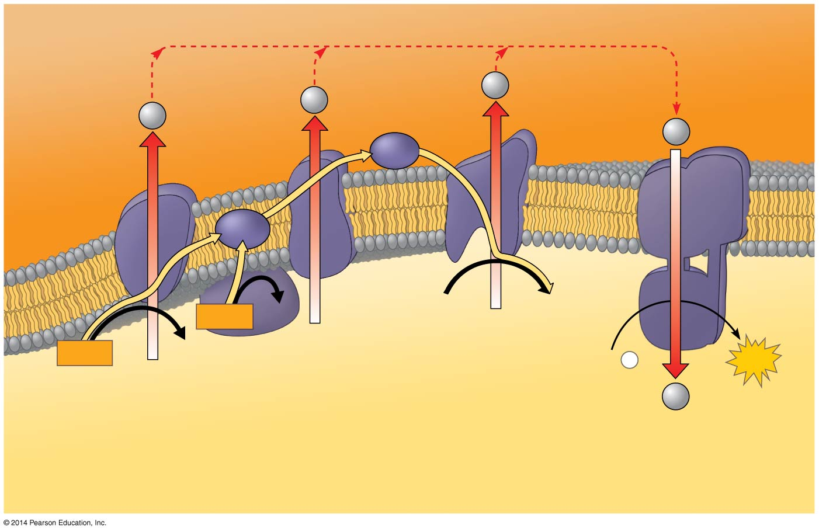
- At this point, you should be able to account for the total number of ATPs that could be formed from a glucose molecule. To accomplish this, we have to add the ATPs formed by the substrate-level phosphorylation in glycolysis and the citric acid cycle to the ATPs formed by chemiosmosis. Each NADH can form a maximum of _______________ ATP molecules. Each FADH2, which donates electrons that activate only two proton pumps, make __________________ ATP molecules.

- Label this figure to show the processes of cellular respiration, the production of NADH and FADH2, and where ATP is formed, and indicate whether it is by substrate-level or oxidative phosphorylation. Use the text to be sure you understand how each subtotal on the bar below the figure is reached.
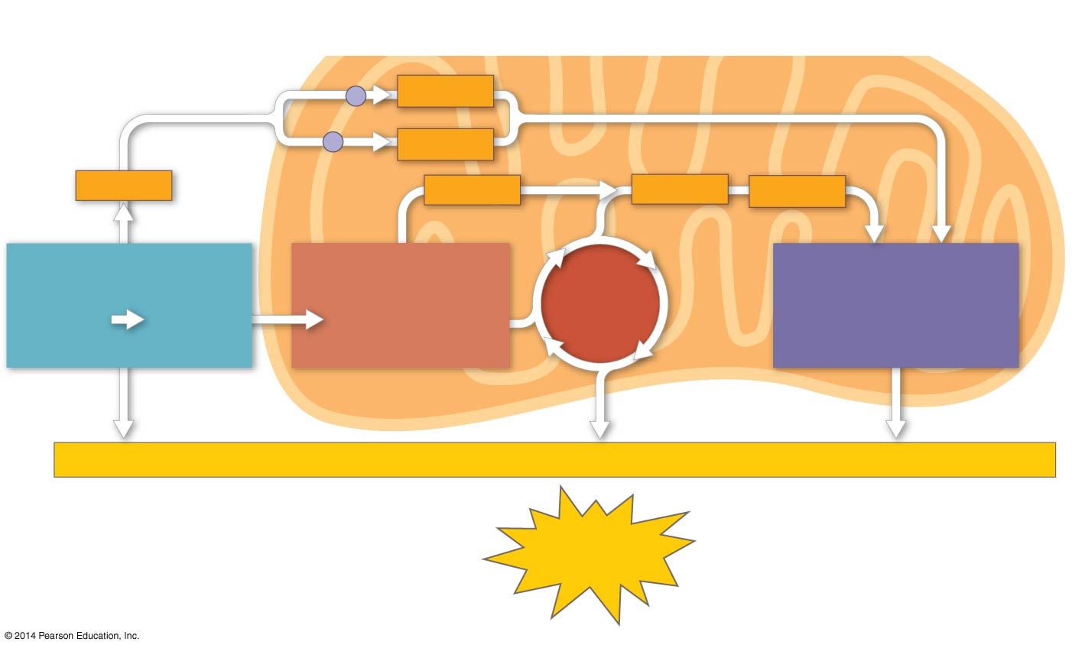

- Why is the total count about 30 or 32 ATP molecules rather than a specific number?

- Fermentation allows for the production of ATP without using either ___________________ or any _______________________.

- For aerobic respiration to continue, the cell must be supplied with oxygen- the ultimate electron acceptor. What is the electron acceptor in fermentation?

- Alcohol fermentation starts with glucose and yields ethanol. Explain this process, and be sure to describe how NAD+ is recycled.

- Lactic acid fermentation starts with glucose and yields lactate. Explain this process, and be sure to describe how NAD+ is recycled.

- Label the following figure and then explain why pyruvate is a key juncture in metabolism.
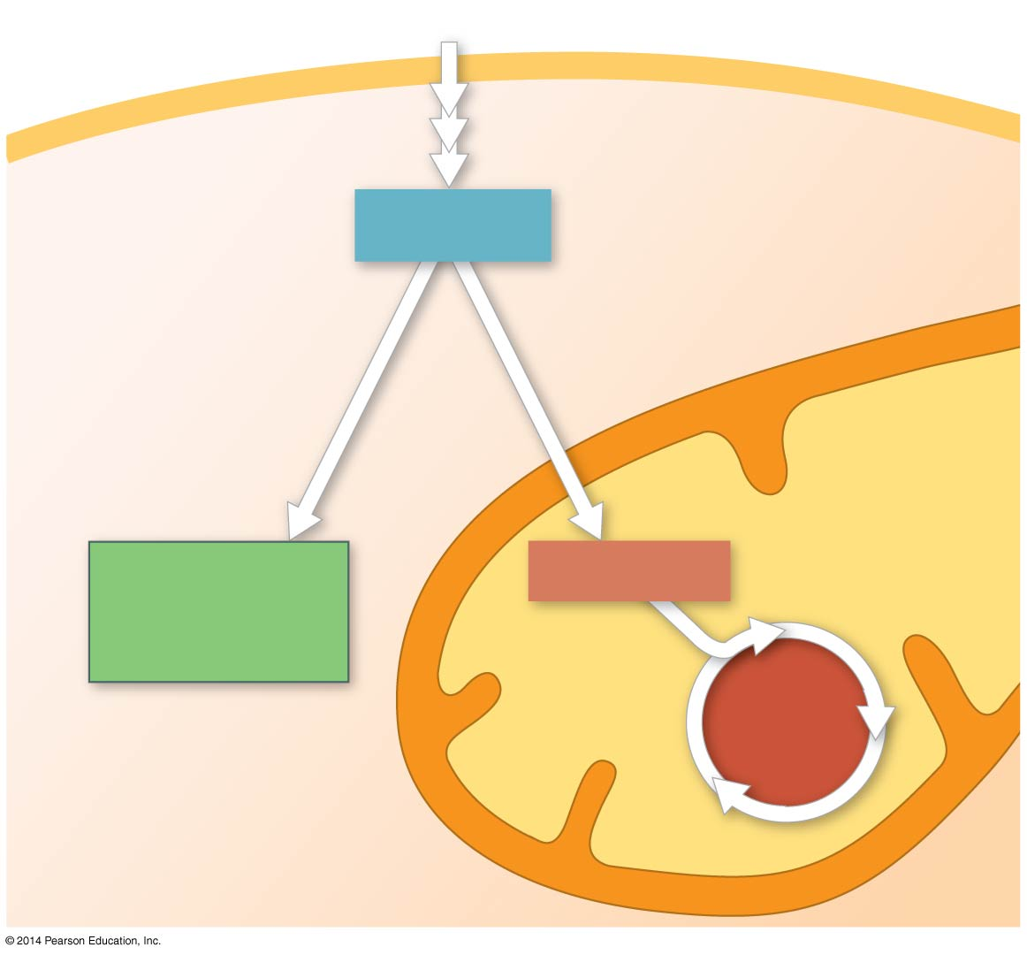

- Glycolysis is thought to have evolved very early in the evolution of life on Earth. Provide three pieces of evidence that justify this hypothesis.

